**Tugas DMBI 4  
FI, AR, dan SP Mining**

Nama:  
Almas Fauzia Wibawa 17/409427/PA/17734  
Bryan Dwison 17/409430/PA/17737  
Fajar Abdul Malik 17/409432/PA/17739  
Faqih Ethana Prabandaru 17/409433/PA/17740

1. **Algoritma Apriori**
2. F1 = {{1}, {2}, {3}, {5}}  
   F2 = {{1,2}, {1,3}, {1,5}, {2,3}, {2,5}, {3,5}}
3. Setelah *join*:

C3 = {{1,2,3}, {1,2,5}, {1,3,5}, {2,3,5}}

Setelah *pruning*:

C3 = {{1,2,3}, {1,2,5}, {1,3,5}, {2,3,5}}

1. F3 = {{1,2,5}, {2,3,5}}
2. *Frequent 3-itemset* yang dipilih = {1,2,5}  
   *Association rule* yang dihasilkan dari *frequent 3-itemset* {1,2,5}:  
   {1,2} → {5}  
   {1,5} → {2}
3. *Frequent closed itemset* = {{1}, {3}, {2,5}}  
   *Frequent maximal itemset* = {{1,3}, {1,2,5}, {2,3,5}}
4. **Algoritma GSP**
5. F1 = {<(1)>, <(2)>, <(3)>, <(4)>, <(5)>, <(6)>}  
   F2 = {<(1)(2)>, <(1)(3)>, <(3)(2)>, <(4)(3)>)
6. Setelah *join*:

C2 = {<(1)(3)(2)>, <(4)(3)(2)>}

Setelah *pruning*:

C2 = {<(1)(3)(2)>}

1. F3 = {<(1)(3)(2)>}
2. *Frequent closed subsequence* = {<(5)>, <(6)>, <(1)(2)>, <(1)(3)>, <(4)(3)>}

*Frequent maximal subsequence* = {<(5)>, <(6)>, <(4)(3)>}

1. **Mushroom.arff**
2. Terdapat **31** *frequent itemset* dengan algoritma **Apriori**.  
   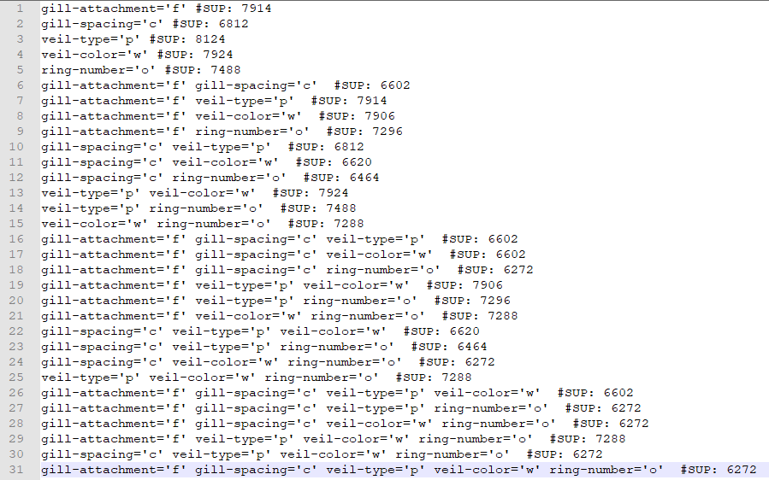
3. Terdapat **12** *frequent closed itemset* dengan algoritma **Apriori closed**.  
   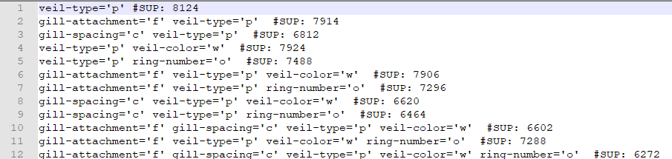
4. Terdapat **1** *frequent maximum itemset* dengan algoritma **FP max**.  
   
5. Terdapat **78** *association rule* dengan algoritma **FPgrowth association rules**.  
   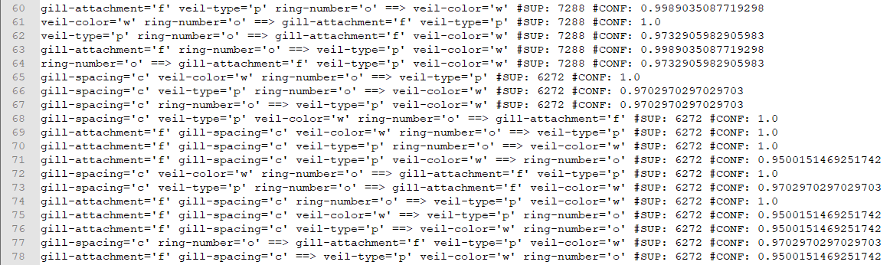
6. Terdapat **44** *closed association rule* dengan algoritma **FPClose**.  
   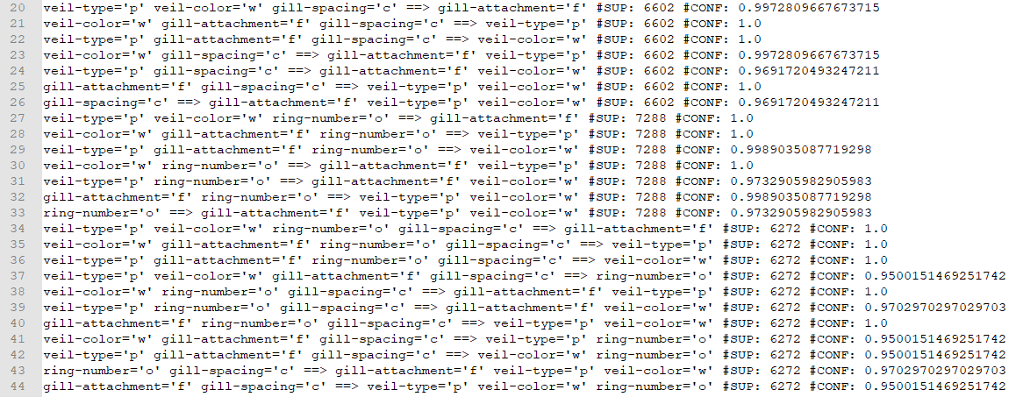
7. **FIFA.txt**
8. Terdapat **938** *sequential pattern* menggunakan algoritma **GSP**.  
   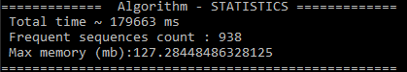
9. Terdapat **295** *sequential pattern* di (a) yang nilai *support count*-nya >5000.  
   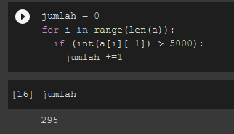
10. Terdapat **111** *sequential pattern* di (b) yang memuat *page* no 135.  
    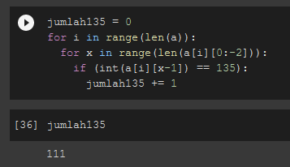
11. Terdapat **277** *closed sequential pattern* dengan algoritma **BIDE+**.  
    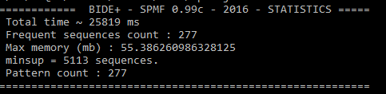
12. Terdapat **237** *maximal sequential pattern* dengan algoritma **MaxSP**.  
    